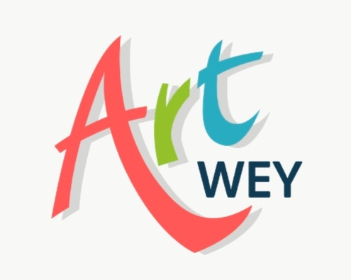
Peace Themed Art Trail
Artwey CIC consists of over 100 artists and we have now been promoting Art in the local community for 15 years. To celebrate this we will be creating a temporary art trail within the town with the theme of Peace it will consist of 15 venues displaying artwork from not only our members but also produced by various other groups including Weymouth college, schools, and other care groups. Maps of the trail will be distributed during the weeks leading up to the event. These maps will include a way to register the venues you have visited, those who completed the trail will be entered into a free draw.

During the course of this event Artwey will be hosting Free workshops for members of the public to create their own work and have the opportunity to have this exhibited on the final day

This Art Trail will commence on Saturday 7th September and finish on United Nations International Peace Day 21st September. To mark this day we will be asking the Mayor to plant a Rose of Peace in the new sensory gardens at Radipole. There will be a free, open to all, celebration where there will be the opportunity to view other artworks, meet members of our team and other invited guests as well as enjoy planned entertainment including music, readings and performing arts.
Feel free to visit our web site, artwey.co.uk where we will update with more details nearer the time.
If you would like any further information or how you can be involved please don't hesitate to contact either Ian or Fran.

Ian iancoxart@yahoo.com
Fran fran@artwey.co.uk

Summer Holiday Project
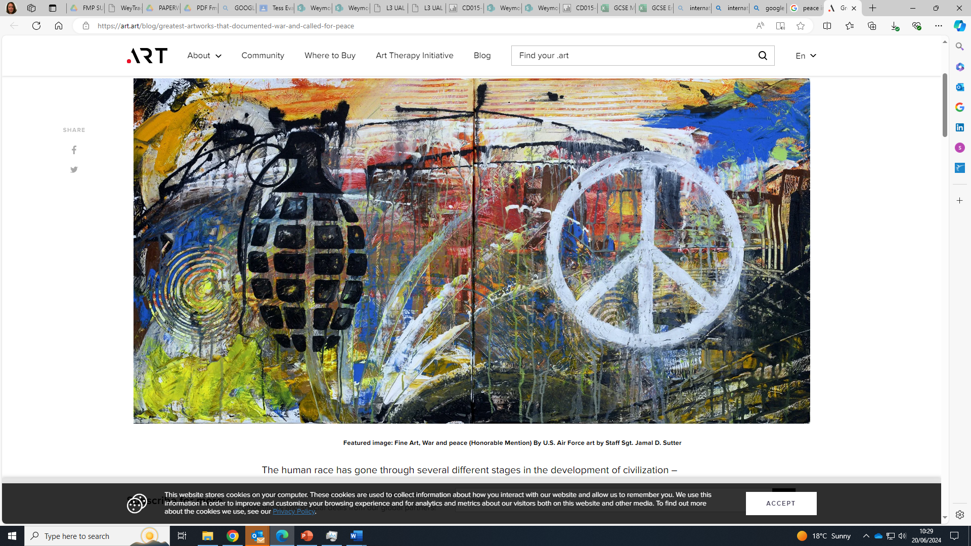
Hello to all soon-to-be year 1 and year 2 students!
Over the summer, we ask you to usually undertake a small project to keep your creative juices flowing.

This year, we would like you to make a piece of work to enter into a competition to form part of the Art Trail as set by ArtWey (see attached information)

The theme is United Nations International Peace Day - a day dedicated to world peace, and specifically the absence of war and violence.

How to start:
I would suggest an initial Google search of terms such as:
- Peace day artwork
- Peace in art
- World peace in art
- International Peace Day
- https://thehistorypress.co.uk/article/peace-symbols-through-history/
- https://www.saatchiart.com/paintings/world-peace/feature

Next:
“Symbols and representations of war and peace have been created throughout history in every genre of art. Before the 17th century, war was typically depicted in art as an admirable achievement – leaders on their horses celebrated their victories as heroes fighting off evil enemies. It was not until the mid 17th century that artists began displaying war in a more self-conscious way that was observant of its horrors and sympathetic to its civilian victims.
Well known images of peace include the dove and olive branch, the peace sign made popular in the 1960’s, the V-sign hand gesture, the rainbow peace flag, the Japanese peace crane, and many others” ART Archives – Page 96 of 107 – Daily Art Fixx.
Consider the visual imagery we have come to associate with Peace, but also consider themes such as:
- Coming together
- Embracing and celebrating differences
- Supporting each other
- What world peace means
- What it means to you
- What it means for others
Making your response:
- Your outcome can be in any media, and any size. I know we have students interested in drawing, painting, textile, fashion, graphic design, photography, sculpture, collage, installation, model making, etc…. please feel free to use whatever processes you wish.
- Remember that if chosen, it will be displayed in a shop window, so very tiny work may not be seen. We would suggest a minimum of A3.
- Consider that your imagery will be on public display and will not be selected if inappropriate. Your work will be representing Weymouth College – make sure it is something you are proud of and willing to show others.
- We have a whole window to display in, so there will probably be multiple selections from your group, depending on sizes and media submitted.
Submit:
Your submission needs to be handed to me at your enrolment interview.
We will select from the artwork submitted for the event happening on the 7th September.
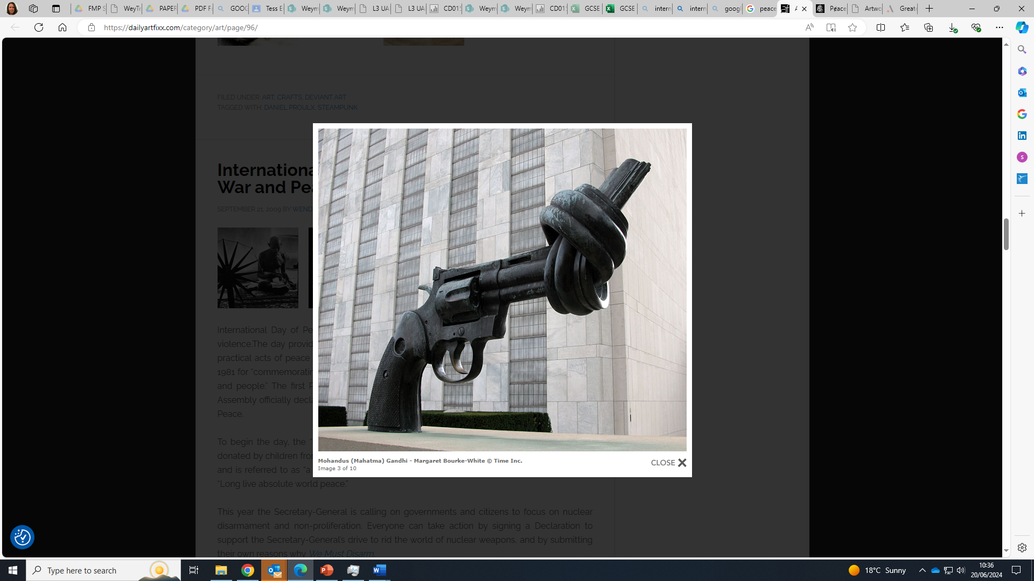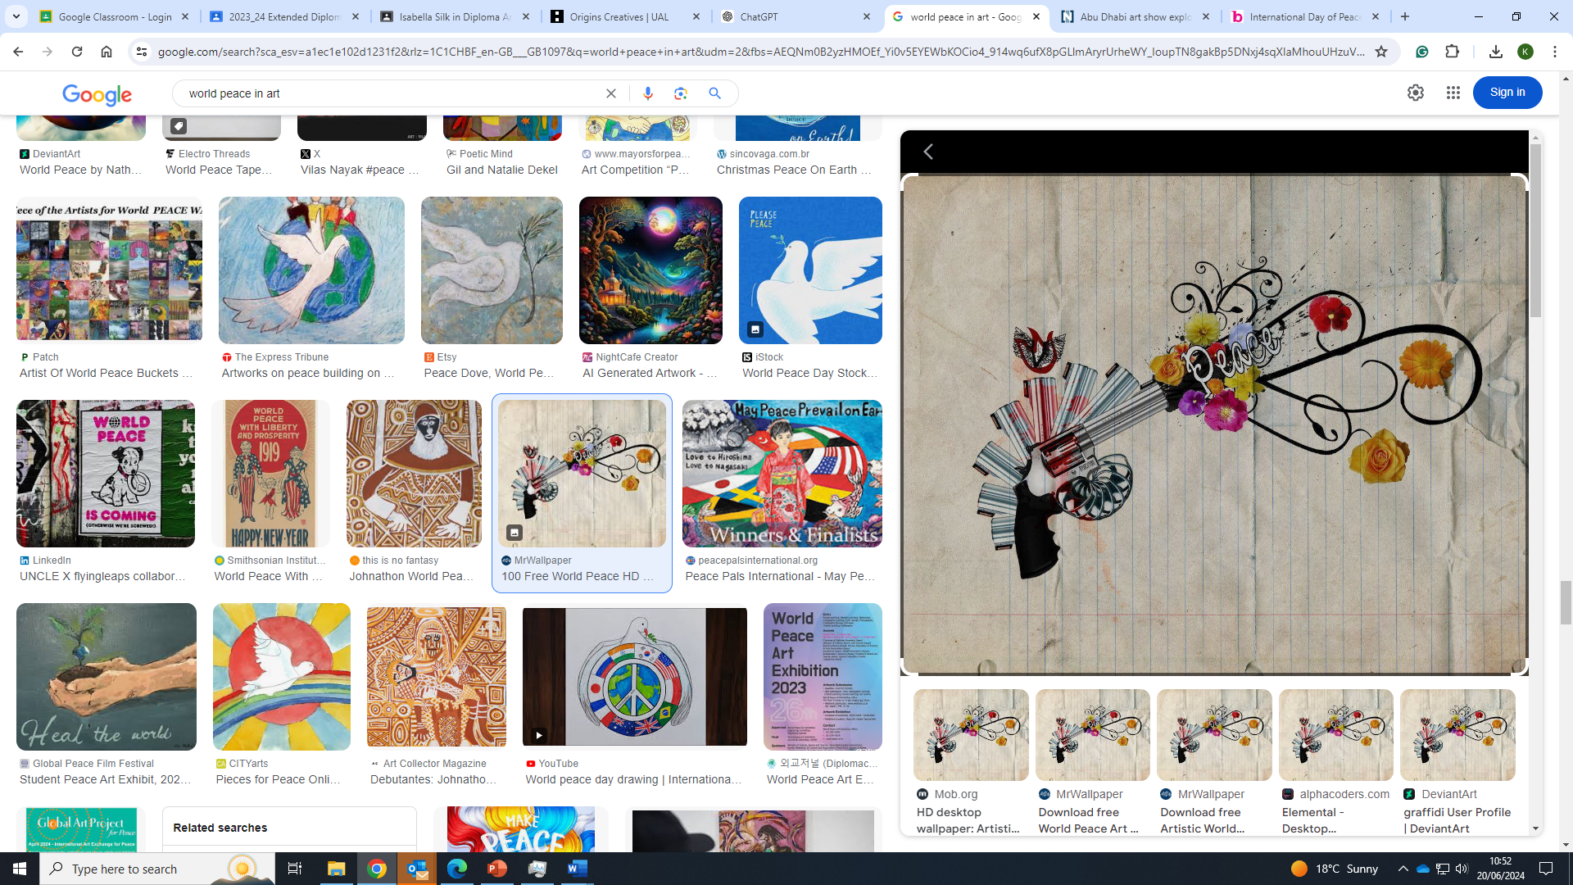
Mohandus (Mahatma) Gandhi – Margaret Bourke-White Downloadable screen wallpaper
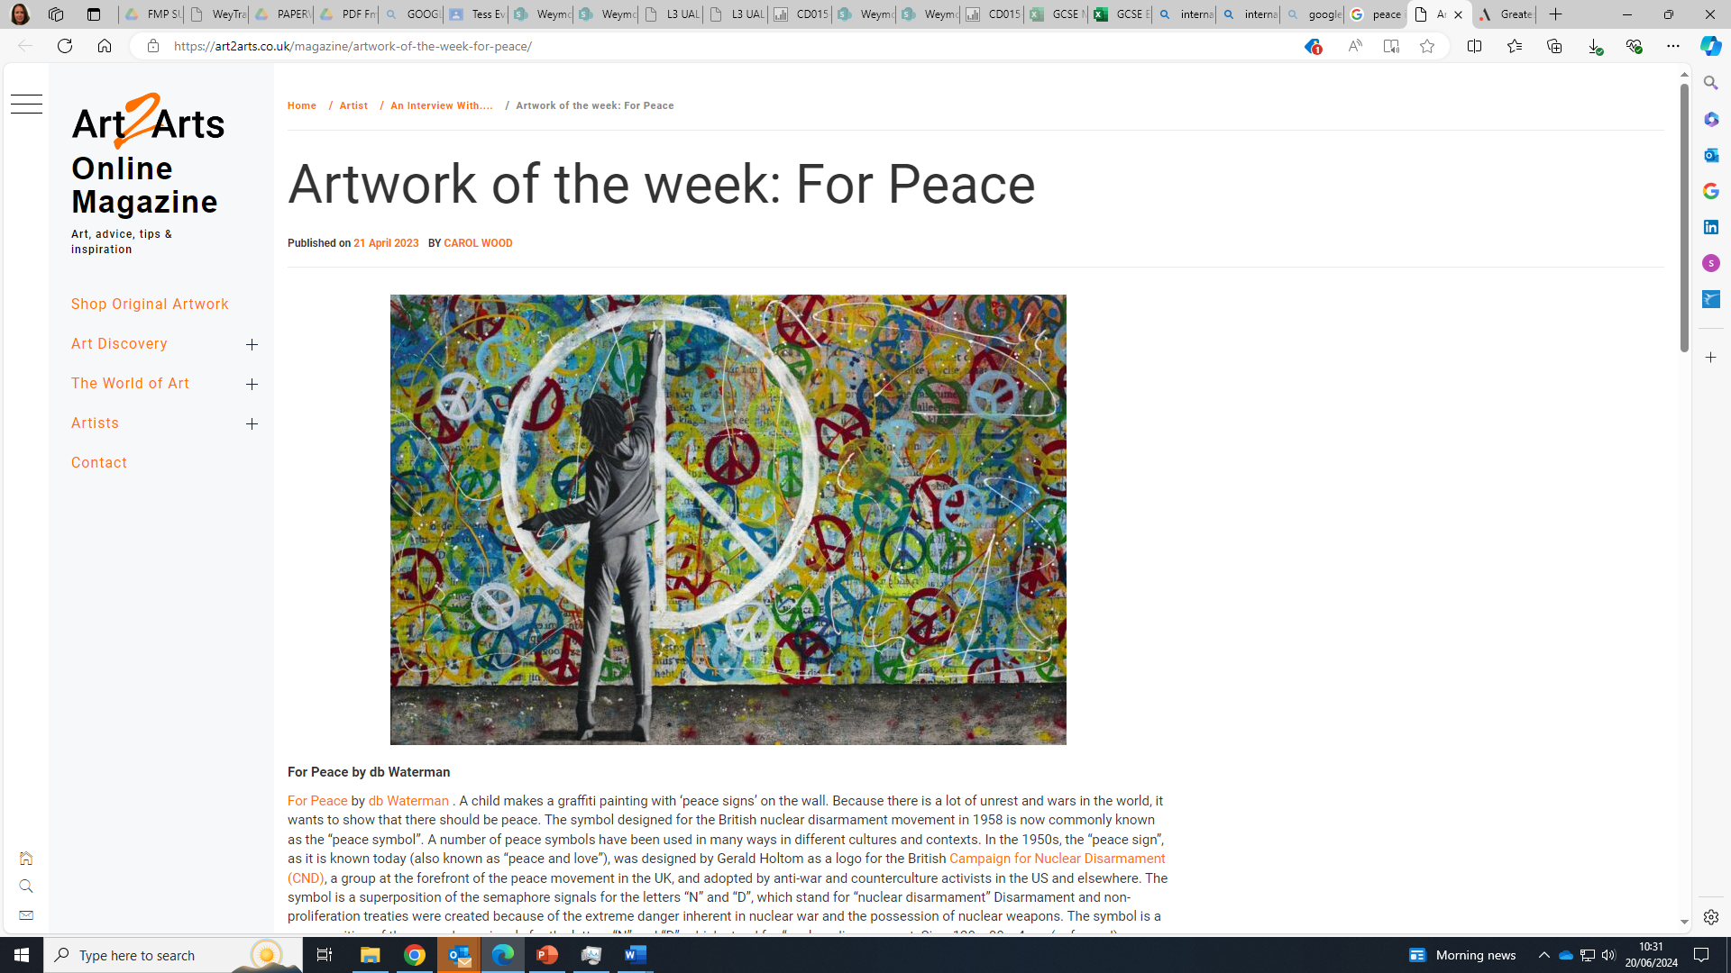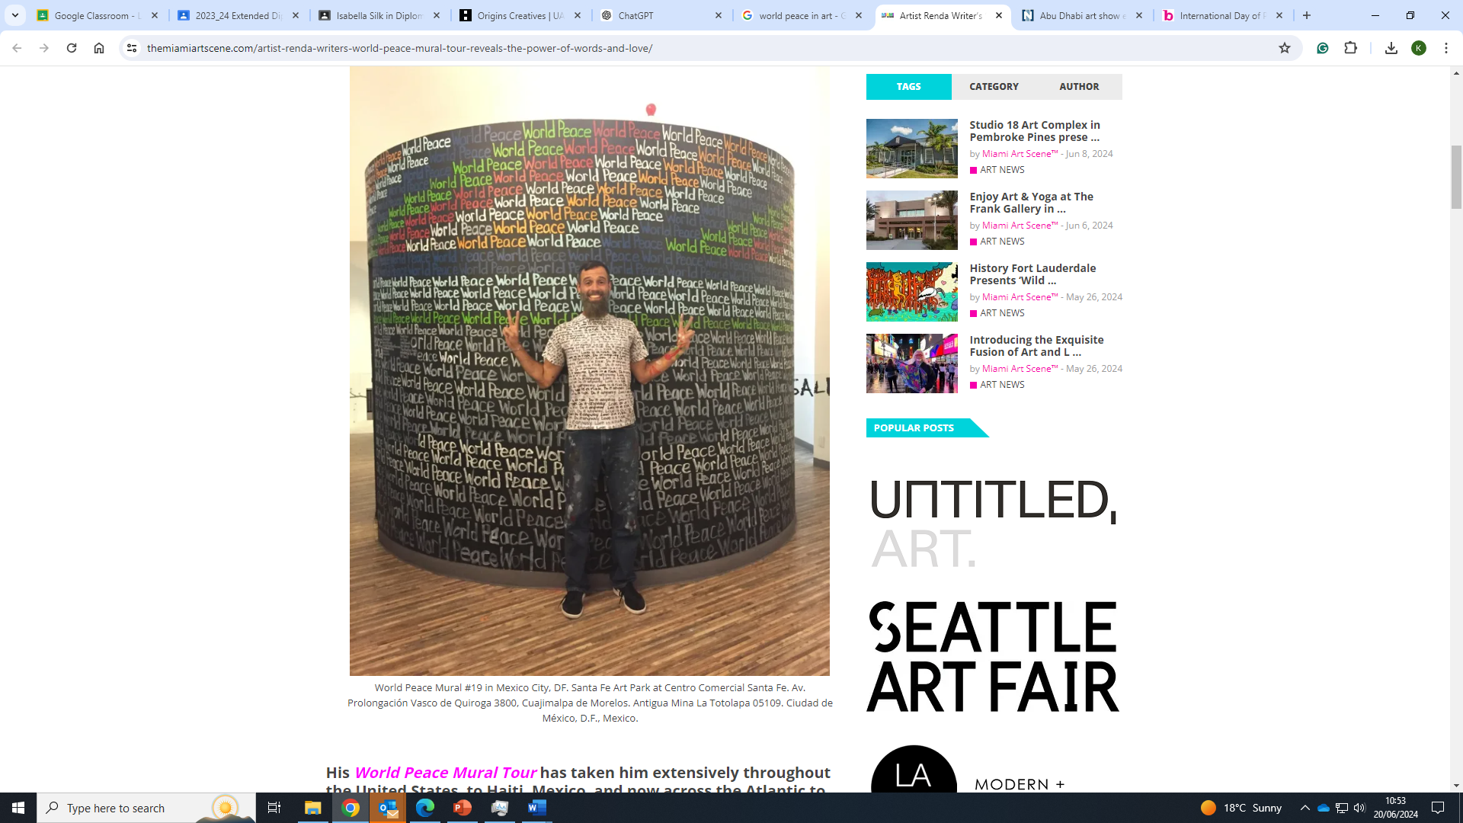
‘For Peace’, by DB Waterman World Peace Mural, Mexico, by Renda Writer
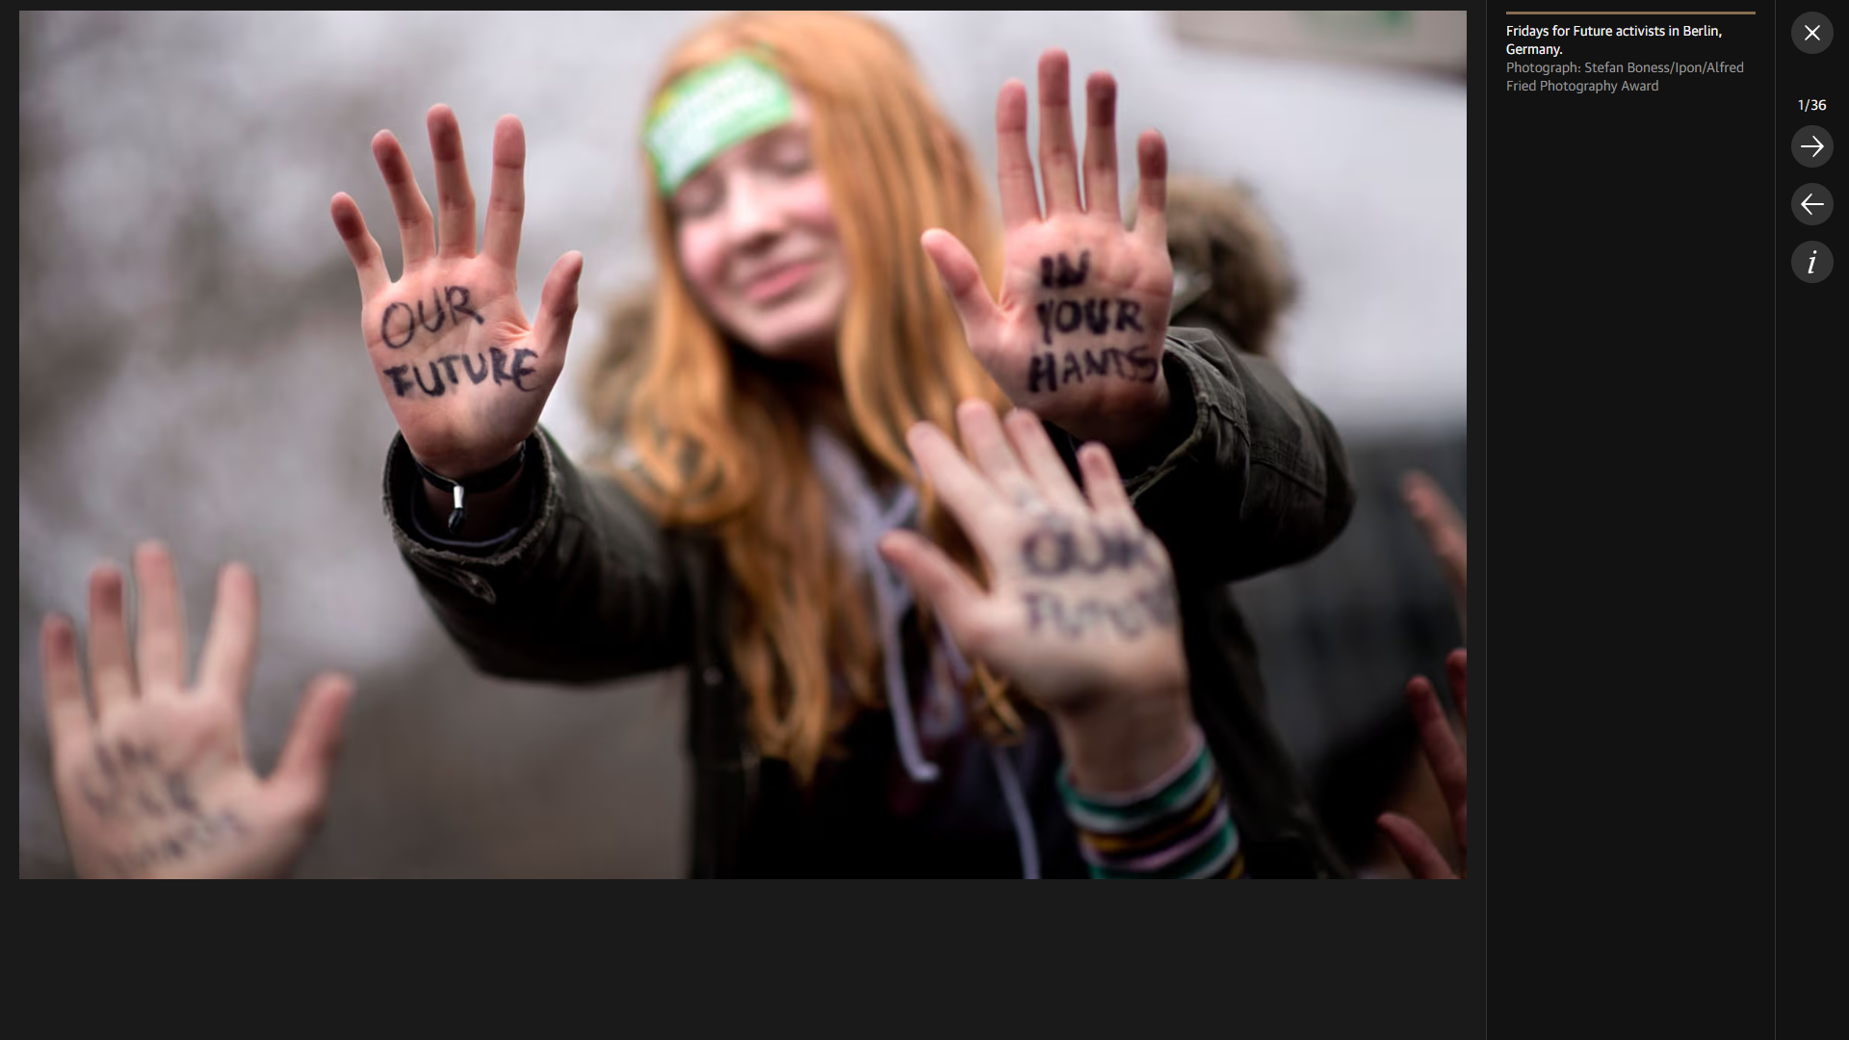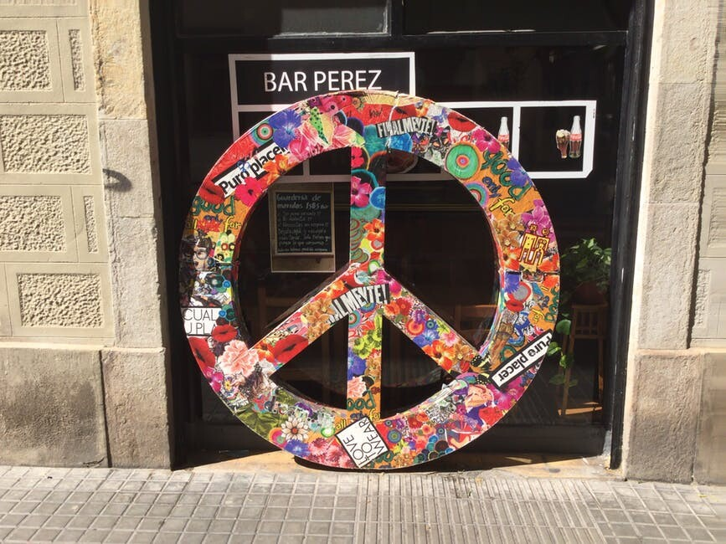
Fridays for Future activists in Berlin, Germany.
Photograph: Stefan Boness/Ipon/Alfred Fried Photography Award.

