
GCSE English Language Summer Homework

Brief Description of Subject:

The GCSE course is designed for learners with a grade 3 or a Level 2 Functional Skills who wish, or need, to improve on their grade. As well as a Speaking and Listening task the course consists of two externally assessed examinations.

Tasks:

Please attempt both of these:

- Look at the pictures attached.
Choose one of the pictures and write a short story of 500 words using the picture. It can be about the scene, or a character or anything you can think of.

- Read the attached extract and answer the questions



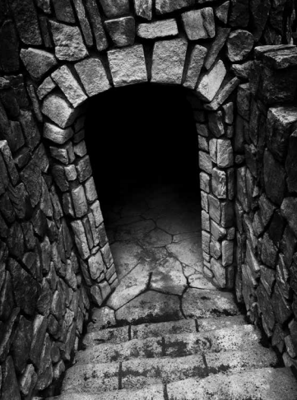

Read the text below and answer Questions 1–4 on the question paper.  This story about a young orphan, Oliver Twist, was written by Charles Dickens in 1838. At this point in the novel, Oliver is living in a workhouse and is nominated by the other boys to request more food.  Adapted from Oliver Twist: Charles Dickens  The room in which the boys were fed was a large stone hall, with a copper at one end; out of which the master, dressed in an apron for the purpose, and assisted by one or two women, ladled the gruel at mealtimes. … The bowls never wanted washing. The boys polished them with their spoon till they shone again; and when they had performed this operation (which never took very long, the spoons being nearly as large as the bowls), they would sit staring at the copper, with such eager eyes, as if they could have devoured the very bricks of which it was composed; employing themselves meanwhile, in sucking their fingers most assiduously, with the view of catching up any stray splashes of gruel that might have been cast thereon. Boys have generally excellent appetites. Oliver Twist and his companions suffered the tortures of slow starvation for three months. At last they got so voracious and wild with hunger, that one boy who was tall for his age, hinted darkly to his companions that unless he had another basin of gruel, he was afraid he might some night happen to eat the boy sleeping next to him, who happened to be a weakly youth of tender age. He had a wild, hungry eye and they implicitly believed him. A council was held; lots were cast for who should walk up to the master after supper that evening and ask for more; and it fell to Oliver Twist.  The evening arrived; the boys took their places. The master, in his cook’s uniform, stationed himself at the copper; his ... assistants ranged themselves beside him; the gruel was served out; and a long grace was said over short commons. The gruel disappeared; the boys whispered to each other and winked at Oliver; while his next neighbours nudged him. Child as he was, he was desperate with hunger, and reckless with misery. He rose from the table; and advancing to the master, basin and spoon in hand, said, somewhat alarmed at his own temerity,–  ‘Please, sir, I want some more.’  The master was a fat, healthy man; but he turned very pale. He gazed with stupefied astonishment on the small rebel for some seconds; and then clung for support to the copper. The assistants were paralysed with wonder, the boys with fear.  ‘What!’ said the master at length, in a faint voice.  ‘Please, sir,’ replied Oliver, ‘I want some more.’  The master aimed a blow at Oliver’s head with the ladle, pinioned him in his arms, and shrieked aloud for the beadle. | 5  10  15  20  25  30

Fiction
Read the text in the Reading Text Insert provided and answer ALL questions.
You should spend 1 hour on these questions.
Write your answers in the spaces provided.
1 From lines 1–3, identify one person working in the hall. (1)

(Total for Question 1 = 1 mark)
2 From lines 3–10, give two ways that the boys’ behaviour shows that they are very hungry. (2)
1
2
(Total for Question 2 = 2 marks)
3 In lines 10–17, how does the writer use language and structure to show the impact of hunger on the boys?
Support your views with reference to the text.
Use the table below to help you plan your answer. (6)
Type of language or structure | Example | Brief notes about the effect of the language/  structure

(Total for Question 3 = 6 marks)
4 In this extract, the writer is talking about the theme of hunger.
Explore how well the writer presents this theme.
In your answer you should:
1. Write about what the writer says about food and being hungry in the extract
2. Give your opinion on how well the writer presents his ideas about food and being hungry
3. Give examples to support your comments. (15)

(Total for Question 4 = 15 marks)
TOTAL FOR PAPER = 24 MARKS

Resources needed:

- You will be advised as to the books needed early in the course

- Please also purchase a folder for your work with file dividers and buy pens, highlighters and paper

