WEYMOUTH COLLEGE CORPORATION
PROFILE OF BOARD MEMBERS
(January 2023)

Determined Membership 17 Quorum = 8
 | Name | Profile | Dates of  Appointment | Committee  Membership
1. | Steve Webb  Chair of the Board | Steve Webb is semi-retired Steve had a degree in Applied Science and a Diploma in Management. He joined the Board in 2012 and has recently given support to Outreach International, a business placing gap/career break individuals throughout the world. Steve’s hobbies include Music, Theatre, Rugby and Walking as well as renovating old properties. | 11/07/2017 – 10/07/2021  2ND term  2 year extension to  09/07/2023 | Search and Governance Committee  Remuneration Committee
2. | Ian Bates  Vice Chair of the Board | Ian joined the Board in February 2020. He is a retired chartered Accountant and chairs the Audit Committee, bringing substantial experience in audit, internal control and risk management, corporate governance and the regulated environment. He has been a governor of a large 6th Form College and through supporting his wife (a teacher and SENCo) in her recent studies for a doctorate in educational psychology he has a keen interest in education. |  | Chair Audit Committee
3. | Jane Nicklen  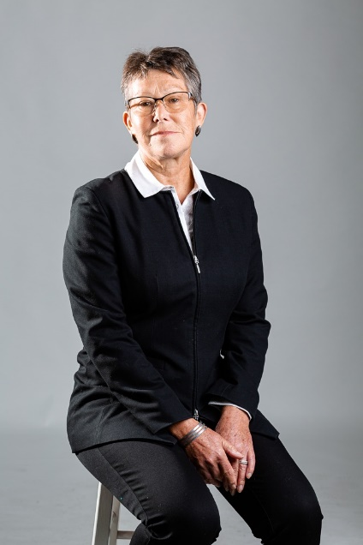 | Jane joined the Board in May 2014. Jane is experienced in Community Planning and Development, Now recently retired, Jane worked for Weymouth and Portland District Council and the new Dorset Council. Jane has a BA degree in Law. | 27 March 2018 to  26 March 2022  2nd term  One year extension to 25/03/2023 | Remuneration Committee Chair.
4. | Jack Dickson | New Member from 11 February 2020  Jack is an Art and Design Teacher and resident Housemaster at Bryanston School (a co-educational private school in Blandford), primarily a pastoral role with responsibility for the welfare of the resident students.  Jack has been working in the private sector for nine years and is keen to reengage with state education in some way. Before moving to Dorset Jack was working in community outreach work as part of a specialist Art, Design and Science School. | 11/02/2020 to  10/02/2024 | Chair Curriculum and Quality Committee
5. | Jacqui Gerrard | Jacqui joined the Board in 2018 as an Associate Member after moving to live in Weymouth, and took up full membership in March 2019. Jacqui has extensive organisational development and strategic HR experience working in executive director and consultancy roles in commercial technology and telecommunications companies and in central government organisations and NHS Trusts. She has previously been a Governor and Chair of a Sixth Form College in Surrey. During her time as Chair, the college merged with an FE college to increase the range of study pathways available to local students. | 11/07/2017 – 10/07/2021  2nd Term | Chair of Finance and Resources Committee
6. | Rod Davis | Joining the Board in 2017, Rod brings experience in Apprenticeships and he is Chair of the local Training Providers’ Network | 06/11/2021 –  05/11/2025  Second term | Member of Curriculum and Quality and Remuneration Committees
7. | Andy Matthews | Andy was appointed in November 2015. Andy is Chair of the Portland Partnership, having worked at one time for the College in a financial capacity; Andy brings much local knowledge and financial expertise to the Board. | 1/11/15-31/10/19  01/11/2019 – 31/10/2023  2nd term | Audit Committee Member
8. | Angela Neuberger |  | 01/04/2021 –  31/03/2025 | Finance and Resources Committee Member
9. | Karen Dyke |  | 09/11/2021 –  08/11/2025 | Curriculum and Quality Committee and Remuneration Committee Member
10 | Ian Girling |  | 13/07/2021 –  12/07/2025 | Audit Committee Member
11 | Chris Evans |  | 12/07/2022 –  11/07/2026 | Finance and Resources Committee Member
12. | Geoff Channon | Newly appointed to the Board. | 13/12/2022 –  12/12/2026
13. | Julia Howe  Chief Executive |  | From 2020 | Search and Governance  Committee
14. | Peter Vowles  Staff Member | Peter has worked in further education for over forty years - in Fiji, Birmingham and Luton before coming to Weymouth. His roles at Weymouth College, as Schools Officer and Student Liaison Officer, bring him into contact with staff and students across the college and with local schools and organisations. He organises Primary College and Careers College for over 3,000 children each year. | 15 May 2018  to 16 May 2022 | Search and Governance  Committee
15. | Second Staff Member  Vacancy | Election planned for January/\February 2023
16. | Teagan Brissett  Student Member |  | From November 2021
17. | Sarah Limm  Student Member |  | From December 2022
Jenny Stiling  Associate/Co-opted Member |  | Jenny has been associated with Weymouth College for nearly twenty years; her area of expertise is in project funding and development. She has been a member of the College Board for a number of years then, moving to an Associate role. | July 2023  (annual review) | Search and Governance Committee
Jason Vaughan  Associate/Co-opted Member |  | Jason is an experienced Financial Accountant working in a senior position for Somerset County Council, | 1/06/2021 – 31/05/2025 | Fiance and Resources Committee
Sue Ratcliffe  Clerk to the Corporation |  | Sue was born and educated in Poole and has worked in education in Dorset ever since. Working in various roles for Dorset Youth Service and then Bournemouth Borough Council before joining Bournemouth and Poole College as Director of College and Customer Services and Clerk to the Corporation. Sue has an HNC in Public Admin, a Master’s Degree in Human Resource Management and a national accreditation in governance and clerking. Now focusing on Governance, Sue was an LSIS Associate until its closure in 2013; she has experience as advisor for two Academy Schools and a trainer/mentor for new clerks. | From 2012

